Andani Mapholi

Ngcebo Ngcobo

Enough Mlimo

Tony Rathelele

Masego Mogale

IT Support Troubleshooting Report

**Network Mapping & Ping Test**

**1. Introduction**

This report presents the results of a network mapping and troubleshooting exercise conducted on the work network. The task involved identifying connected devices, retrieving IP configuration details, and testing connectivity using the ping command to verify local and external communication.

**IP Configuration Results (ipconfig)**

The following details were obtained from the Windows workstation:

* IPv4 Address: 172.20.7.186
* Subnet Mask: 255.255.254.0
* Default Gateway: 172.20.6.1

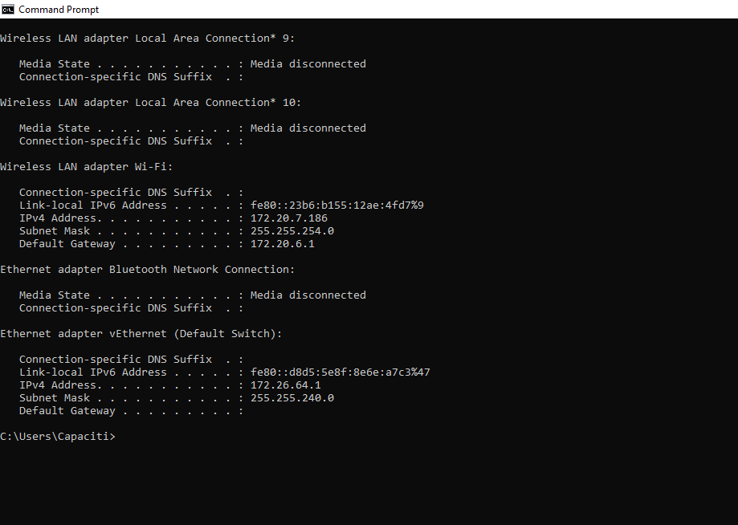

**Ping Test Results**

Connectivity tests were carried out using the ping command:

* **Ping to Router (172.20.6.1)** → Success, average reply <5ms

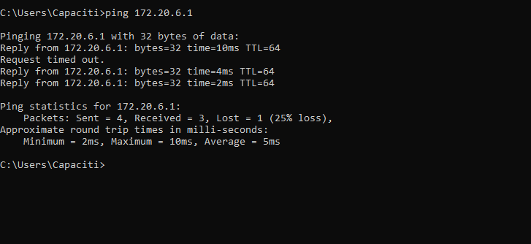

**Ping an External IP (Google DNS):**

* **Ping to External IP (8.8.8.8)** → Success, average reply 31ms

**Ping a Domain Name (DNS Resolution Test):**

* **Ping to Domain (www.google.com)** → Success, average reply 12ms, DNS resolution successful

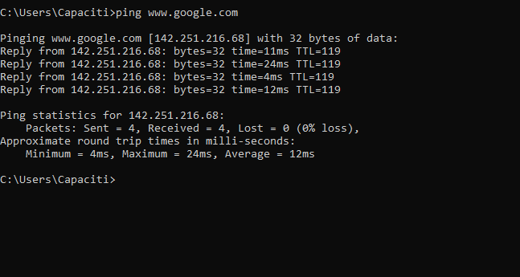

**Network Mapping**

The work network is connected via an office router that provides access to the internet through the Internet Service Provider (ISP). The following devices are connected to the network:

* Work PC (Windows)
* Colleague’s laptop
* Office printer
* VoIP phone
* Router (gateway to ISP)

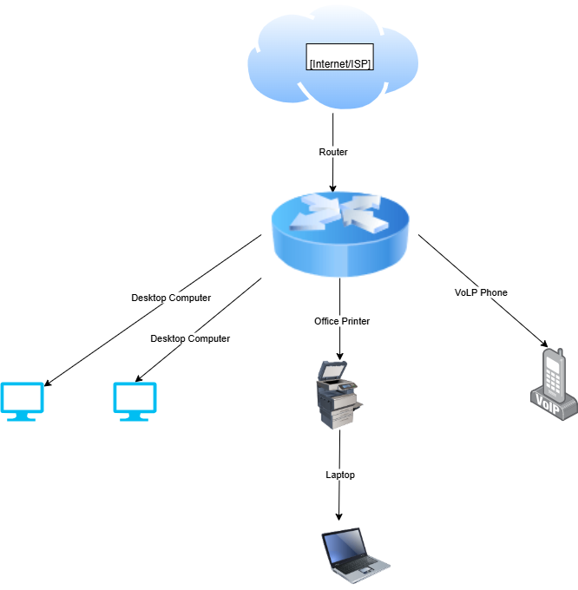

**Conclusion**

The work network is fully operational. Devices can communicate with the router, access the internet, and resolve domain names successfully. This confirms that both local connectivity and external connectivity are functioning without issues.